Summer Training Report

Submitted in partial fulfilment of requirements for the award

of the degree of

**Bachelor of Technology**

**In**

**Computer Science**

C++ Programming

Undertaken at

# Codsoft



**UNIVERSITY SCHOOL OF INFORMATION, COMMUNICATION AND TECHNOLOGY GURU**  **GOBIND SINGH INDRAPRASTHA UNIVERSITY**

**Submitted By:**

**Name: AYUSH RAWAT**

**Enrollment No: 00716403221**

**Branch: BTECH CSE (5th sem)**

# DECLARATION

I CHAHAT, a student of Information Technology, Vth semester in

University School of Information, Communication & Technology, Dwarka hereby declare that the work presented in this Summer Internship report was undertaken from 1/08/2023 to 31/08/2023.

under the guidance of Codsoft Pvt.Ltd.

The matter embodied in this project report has not been submitted by me or anybody else to any institution for award of any other degree or diploma except to University School of Information, Communication &Technology, for the fulfilment of the requirements for the award of degree of Bachelor of Technology.

Chahat

05516401521

# Acknowledgement

I would like to express my sincere gratitude to everyone who contributed to my successful completion of the C++ internship at Codsoft.

Firstly, I would like to extend my deepest thanks to Codsoft for offering me this valuable internship opportunity. Their guidance, support, and encouragement throughout the program were invaluable. They helped me improve my skills and knowledge significantly.

It has been the most rewarding and motivational experience for me. It has truly been a transformative experience.

The projects I've worked on during this internship have been instrumental in reaching my goal of successfully completing this journey. The challenges I've faced during my internship have helped me develop problem-solving skills, resilience, and a strong work ethic.

These invaluable experiences have not only enriched my professional growth but have also left me feeling well-prepared to excel in both my career and personal pursuits moving forward.

Finally, I am deeply grateful to my family and friends for their unwavering support and encouragement. Their belief in me helped me stay motivated and focused throughout the internship.

Thank you to everyone who made this internship a truly enriching and unforgettable experience.

## About organisation

CodSoft is innovative IT services and consultancy. We specialize in crafting cutting-edge solutions for businesses, driven by our passion for technology and the transformative power of software.

We actively invest in the future through our impactful internship program. At CodSoft, we recognize that practical knowledge is crucial to success in the tech sector. Through hands-on learning via live projects and realworld examples, we bridge the gap for students lacking foundational skills.

Our team comprises industry experts dedicated to equipping interns with the knowledge and skills essential for thriving in their careers. We foster an inclusive and supportive environment that nurtures learning, encourages growth, and sparks creativity.

## Overview

C++ programming stands as a versatile and influential language renowned for its efficiency, flexibility, and wide-ranging applications. Originating as an extension of the C language, C++ incorporates key features like objectoriented programming (OOP) principles, enabling developers to create modular, reusable code structures. Known for its robust performance, C++ is often the language of choice for system-level programming, game development, and high-performance applications. The inclusion of the Standard Template Library (STL) further amplifies C++'s capabilities, providing a rich set of pre-built classes and functions that enhance productivity.

During the internship period, I was provided with three projects. It was to be created using C++ and had to be submitted within a month.

The three of the tasks were as follows:

1. Simple Calculator
2. Student Grading System
3. Number Guessing Game

### Projects

Simple Calculator :

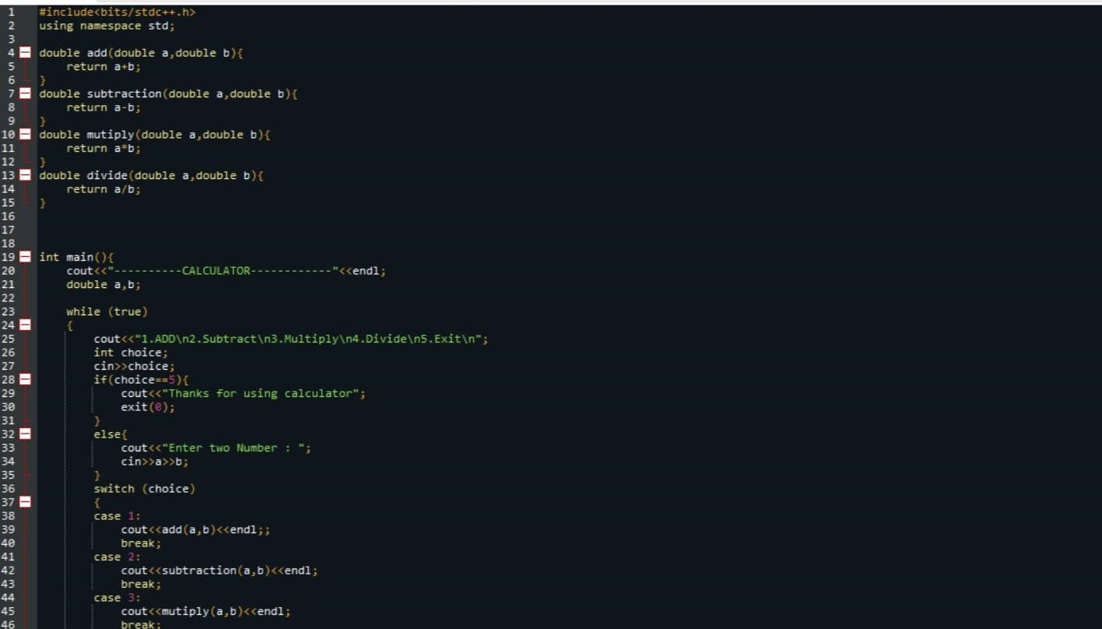

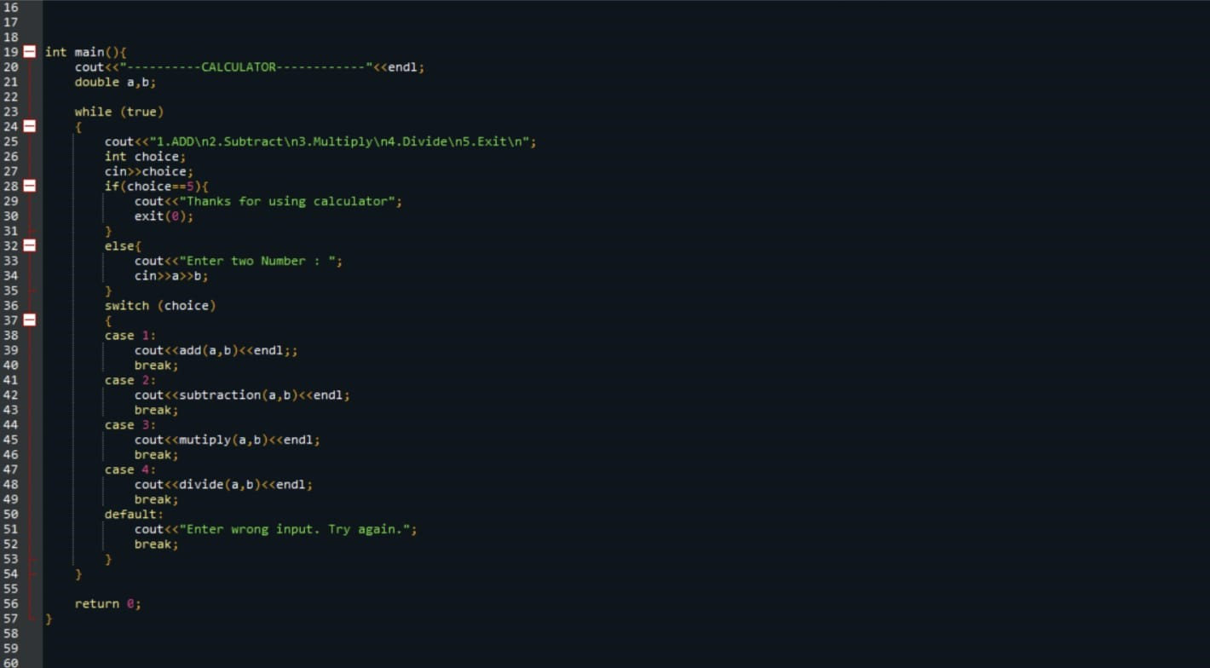

OUTPUT :

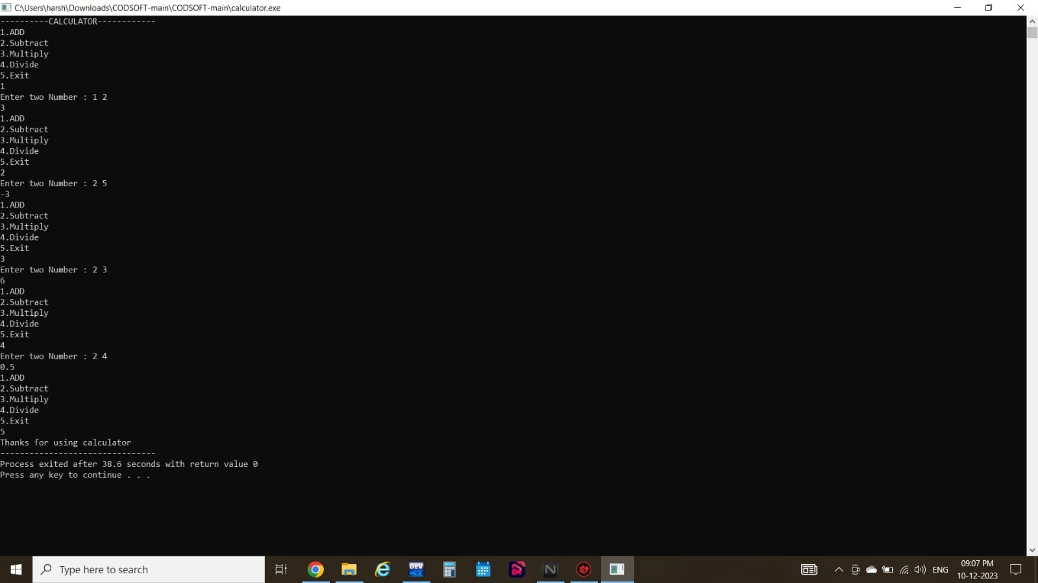

Student Grading System :

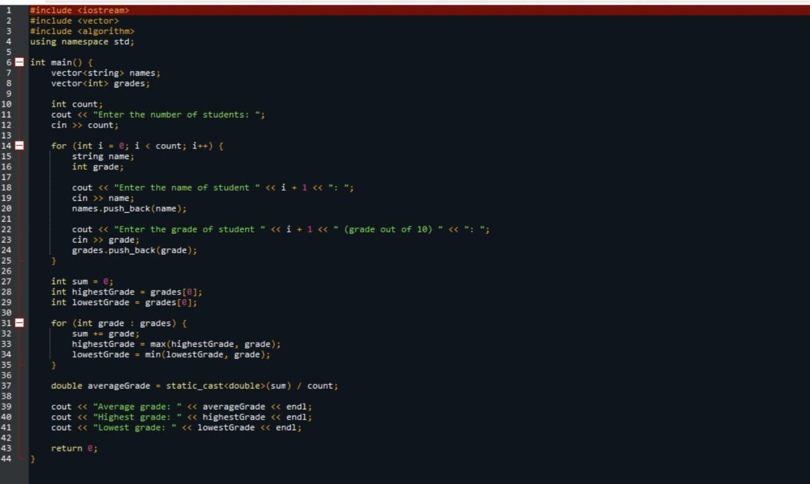

Output :

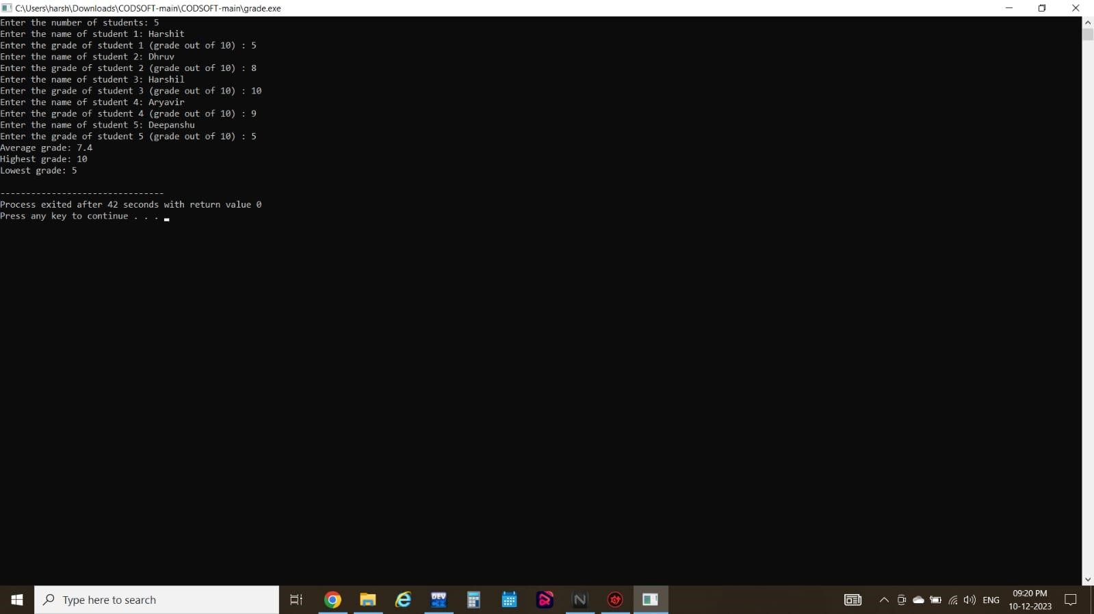

Number Guessing Game :

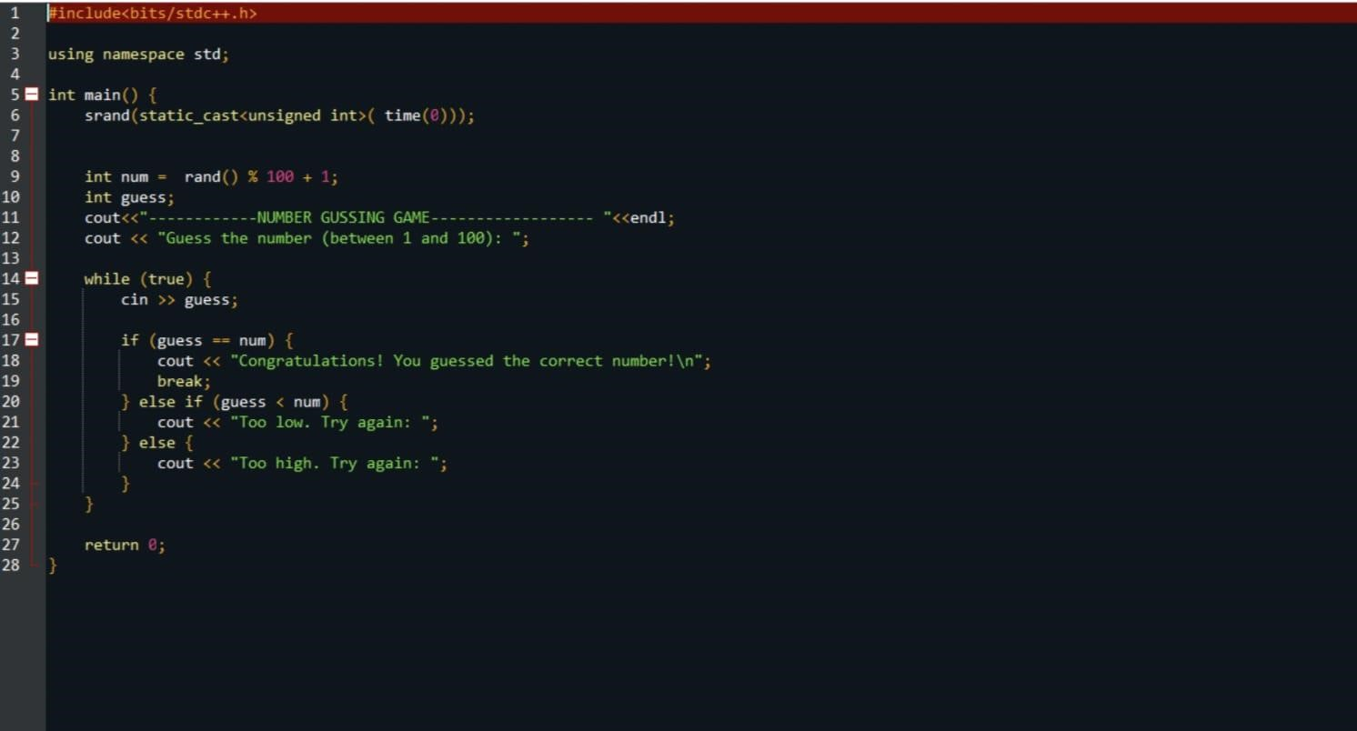

Output :

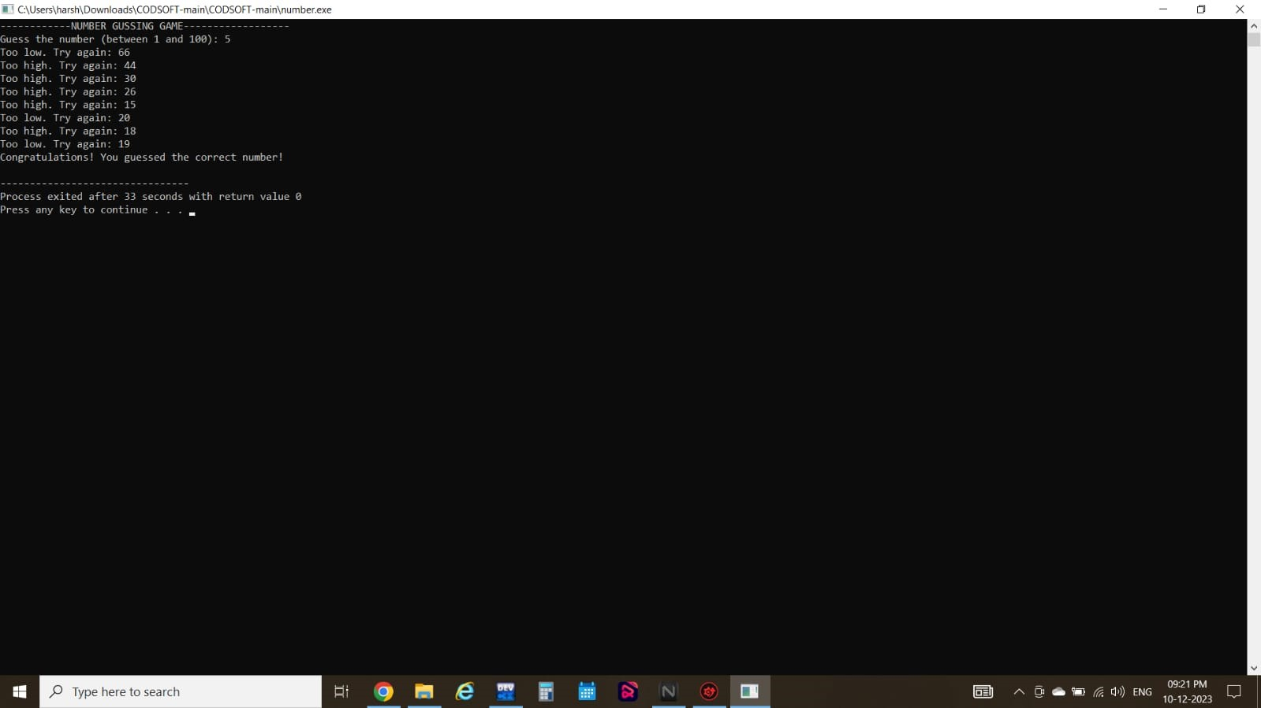

**Technical Skills Learned**

Throughout the internship, I gained valuable knowledge and experience in the following areas:

C++ Programming : Proficient use of C++ language features, syntax, and concepts. Writing modular, reusable, and efficient code in C++. Debugging and troubleshooting C++ code.

Object Oriented Programming : Designing and implementing classes and objects. Understanding and applying OOP principles such as encapsulation, inheritance, and polymorphism.

Memory Management : Dynamic memory allocation and deallocation. Avoiding memory leaks and optimizing memory usage.

Integrated Development Environment : Familiarity with popular C++ IDEs, like Visual Studio or Code::Blocks. Utilizing features of the IDE for code editing, debugging, and profiling.

Version Control : Using version control systems, such as Git, for collaborative coding. Understanding branching, merging, and code repositories.

### Future Scope of Work

Based on my experience at Codsoft, I am eager to continue expanding my coding skills and knowledge. I am particularly interested in learning more about coding . The internship at CodSoft has laid the groundwork for an expansive future scope of work in C++ programming, offering numerous avenues for professional growth and contribution. Moving forward, one area of focus could be the exploration of advanced C++ concepts, including template metaprogramming and a deeper understanding of the Standard Template Library (STL). As the internship provided a solid foundation, delving into software architecture and design patterns offers an opportunity to elevate projects to a more sophisticated level, enhancing scalability and maintainability. Engaging in larger-scale project development will be pivotal, allowing for a comprehensive understanding of the software development life cycle and the management of complex codebases.

### Conclusion

My summer internship at Codsoft was a rewarding and enriching experience that provided me with valuable insights into the world of coding. Looking ahead, I am excited to expand my knowledge and delve deeper into the world of coding. My commitment to mastering best practices and staying abreast of the latest trends will fuel my journey.I am grateful for the opportunity to learn from experienced professionals and apply my skills to real world projects. I am confident that the knowledge and skills gained during this internship will be instrumental in my future career.

### Certificate of completion

